**SOURCE CODE OF FORM BUILDER WITH BACKEND OF OF DATA BASE**

**LOGIN BUTTON**

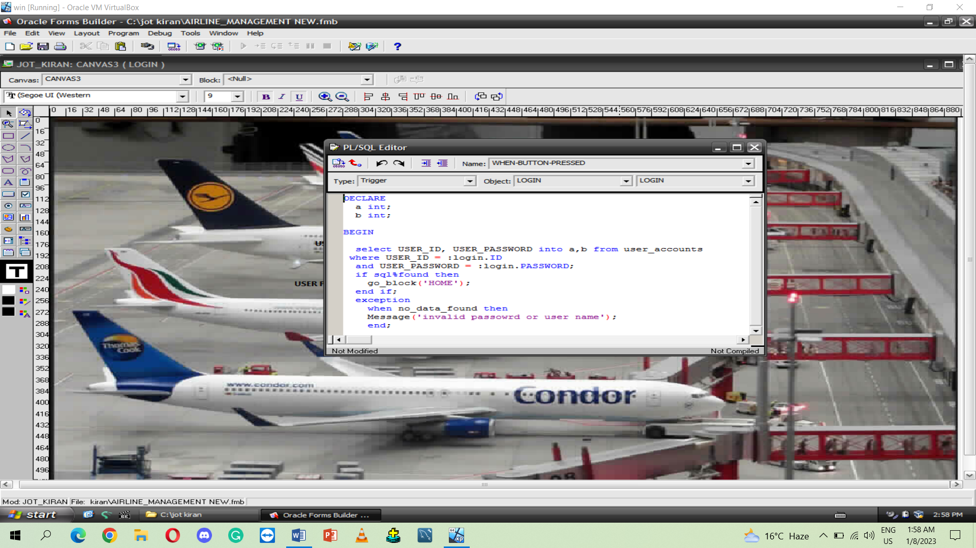

**EXIT BUTTON QUERY**

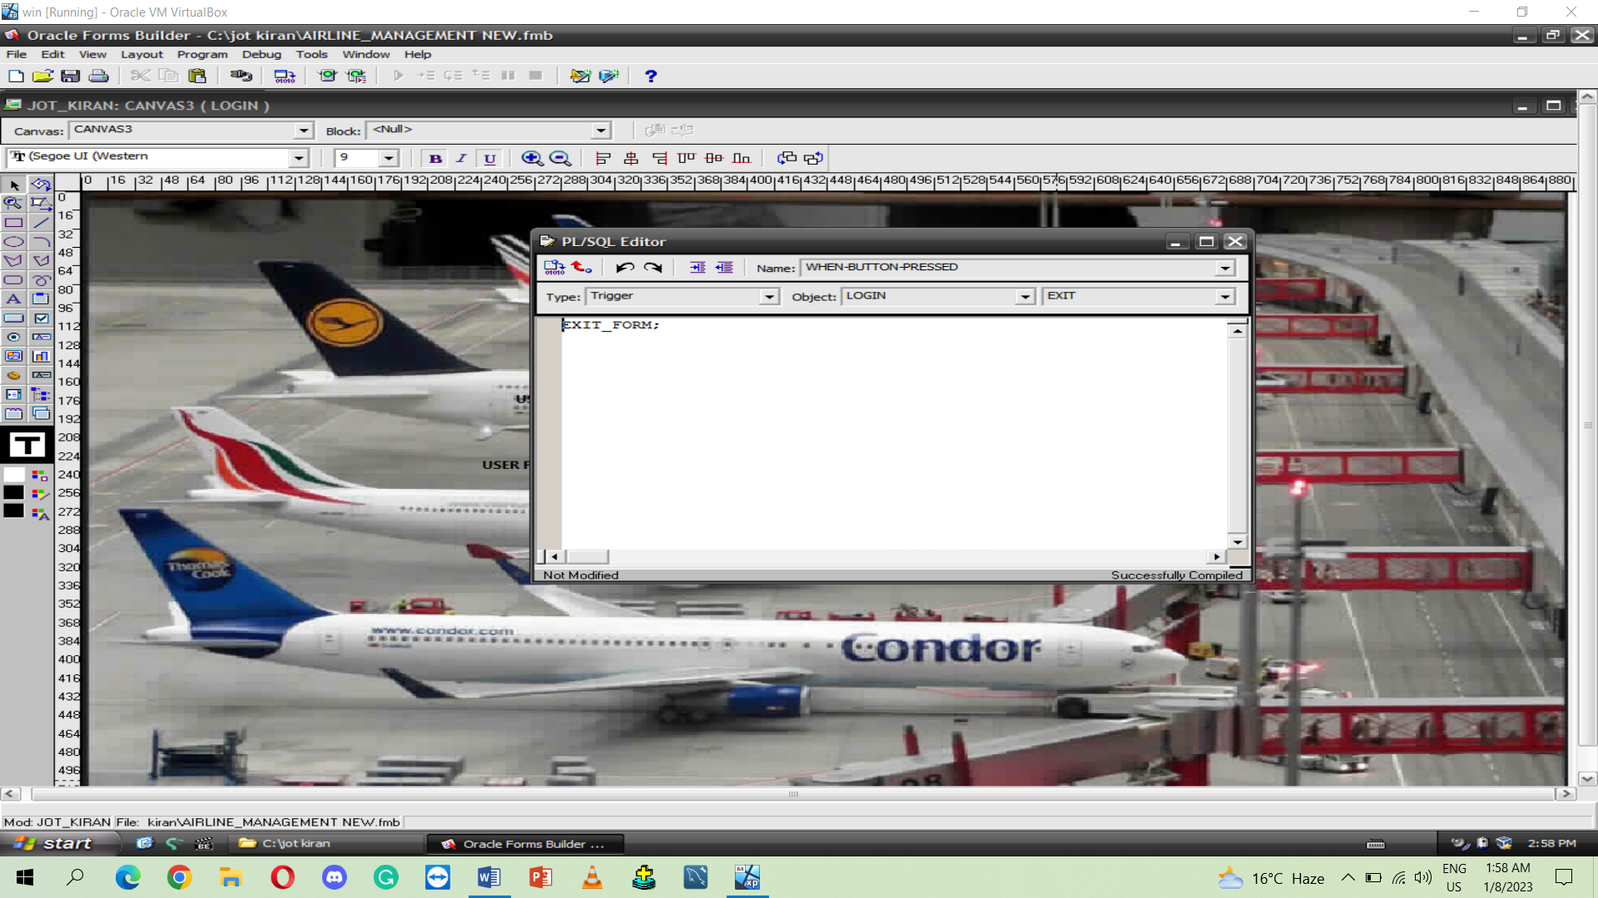

**Show the block BUTTON QUERY**

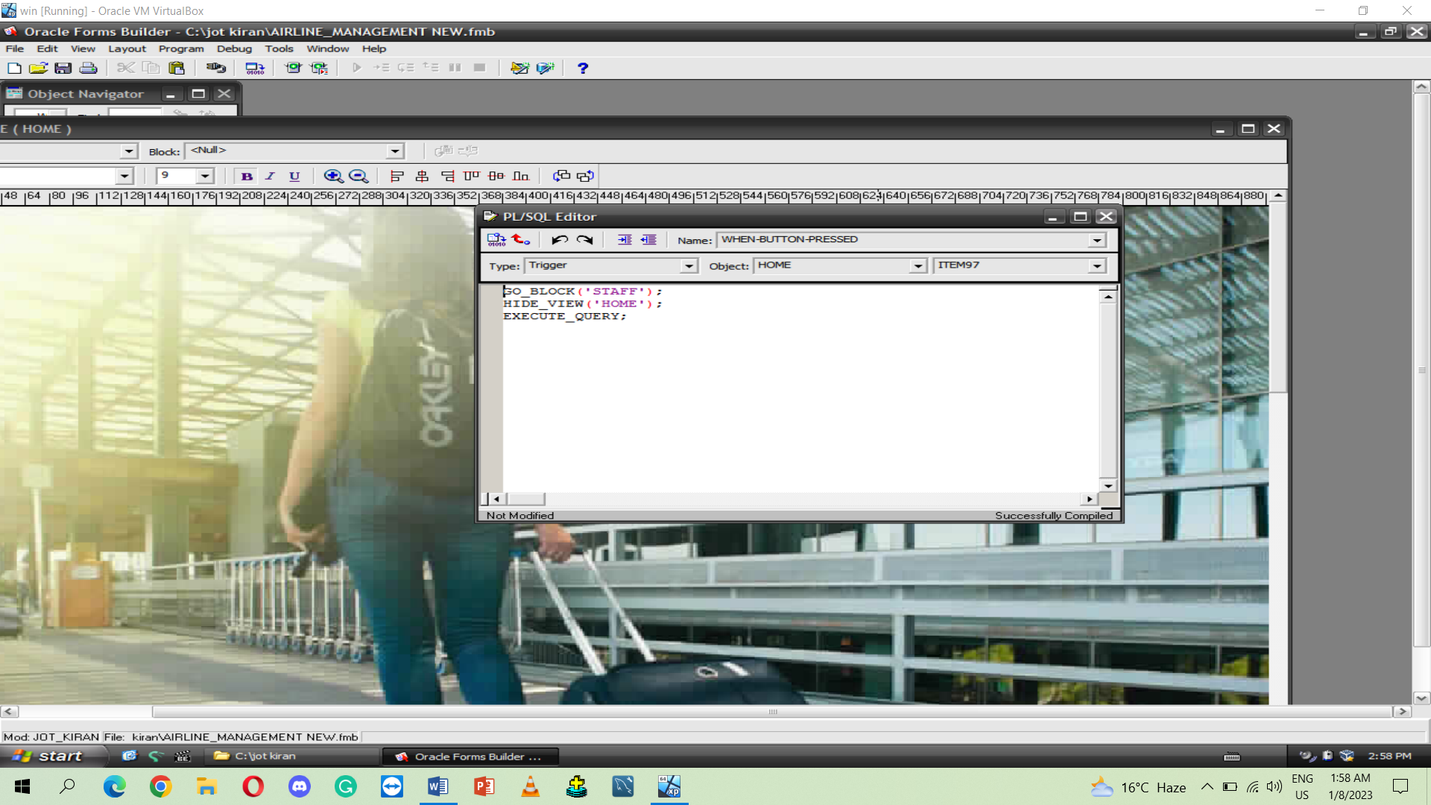

**UPDATE BUTTON QUERY**

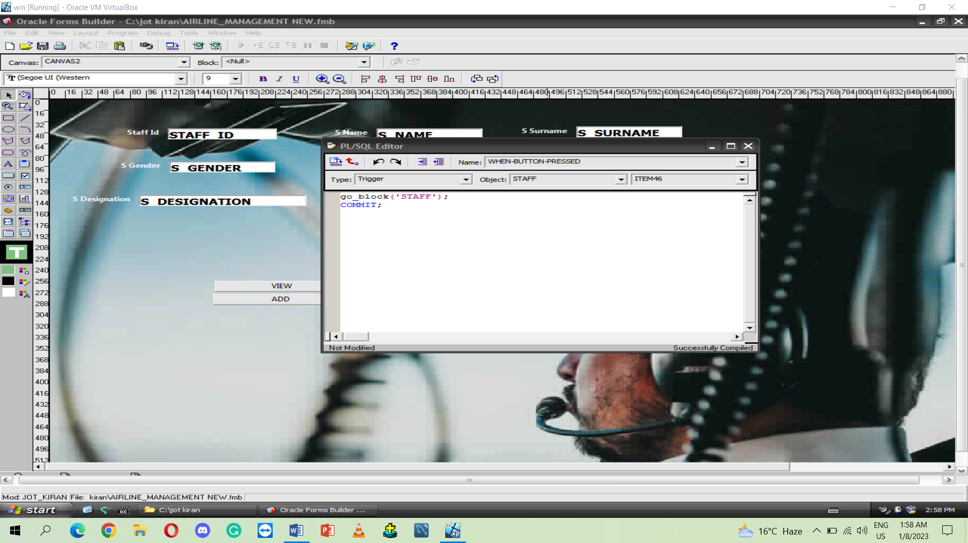

**VIEW BUTTON QUERY**

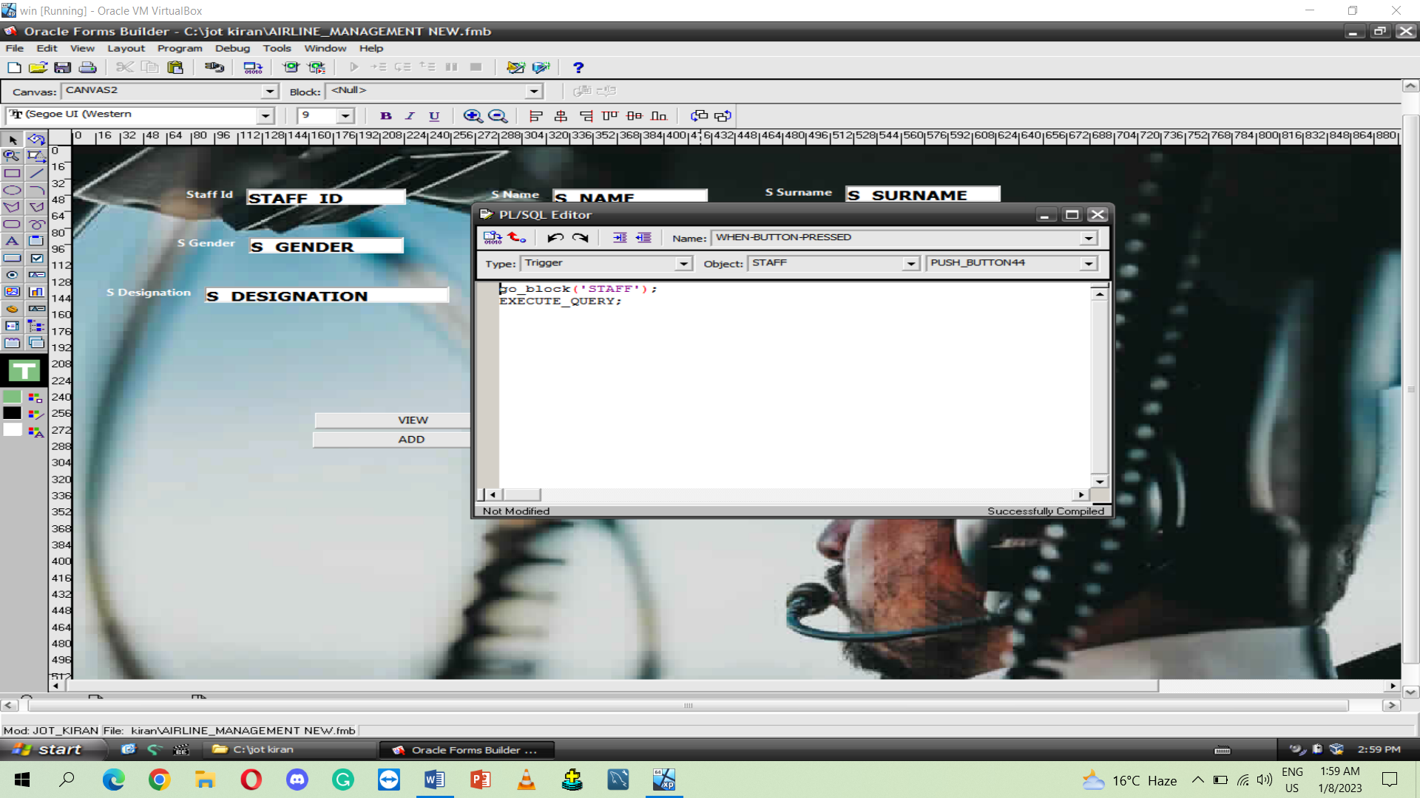

**ADD BUTTON QUERY**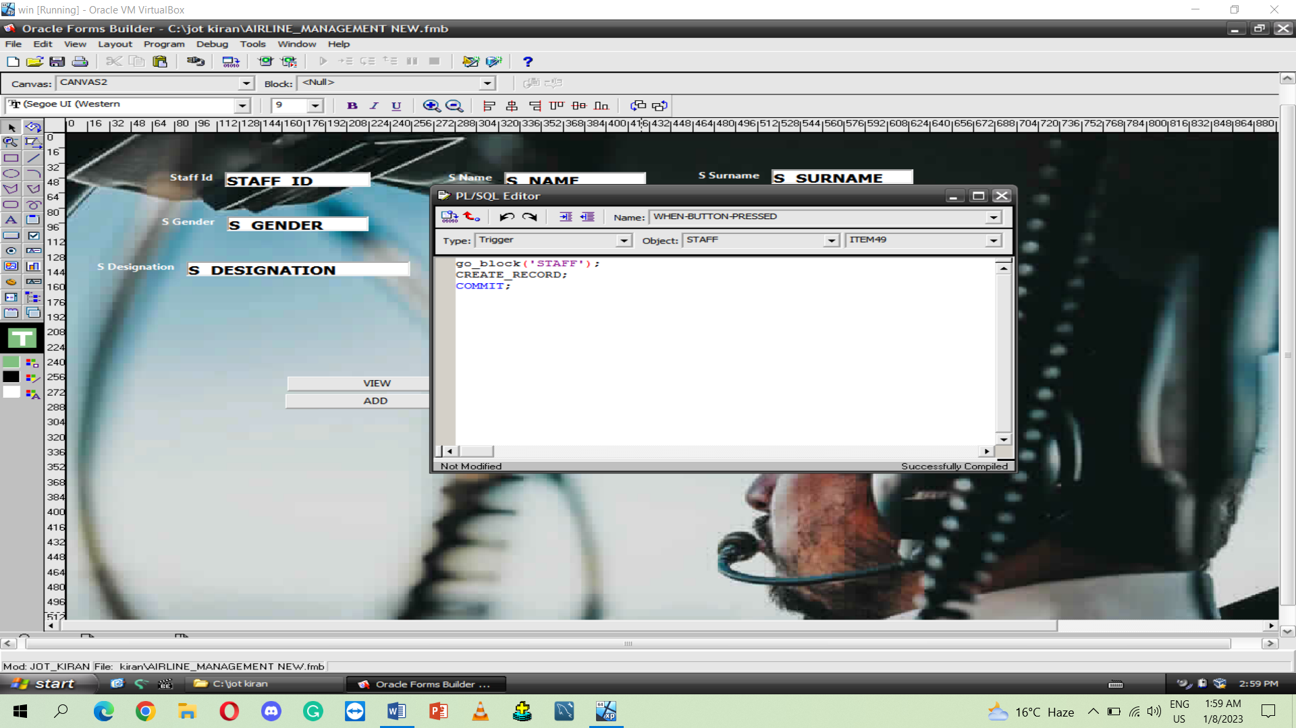

**DELETE BUTTON QUERY** 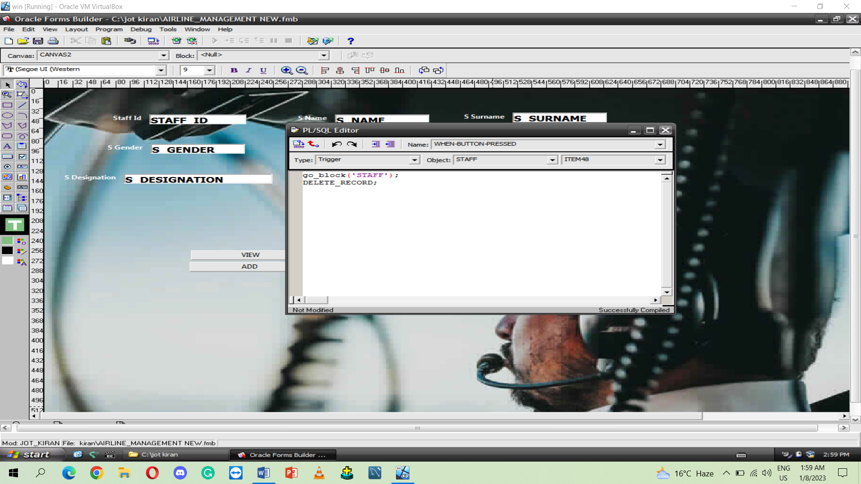

**GO BACK BUTTON QUERY** 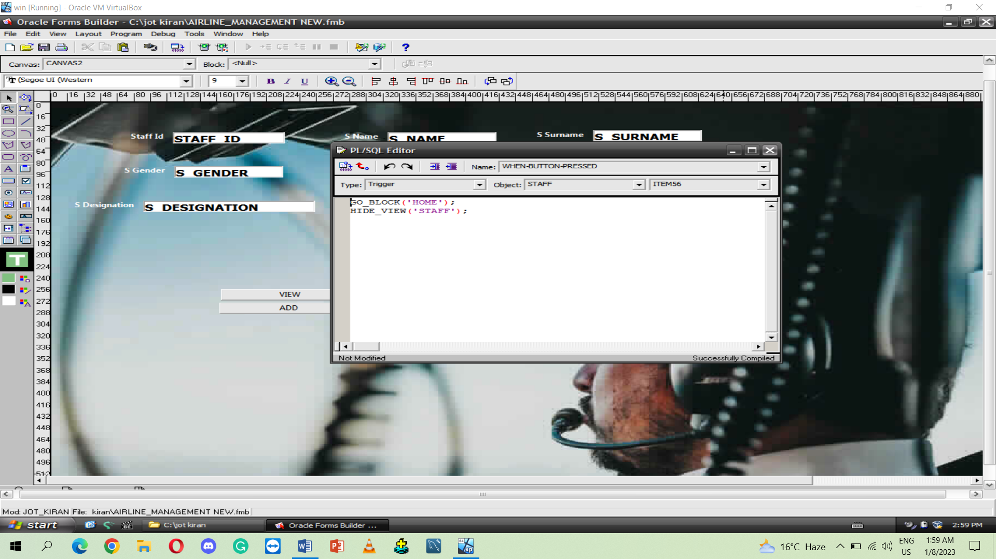

**SEARCH BUTTON BUTTON QUERY**

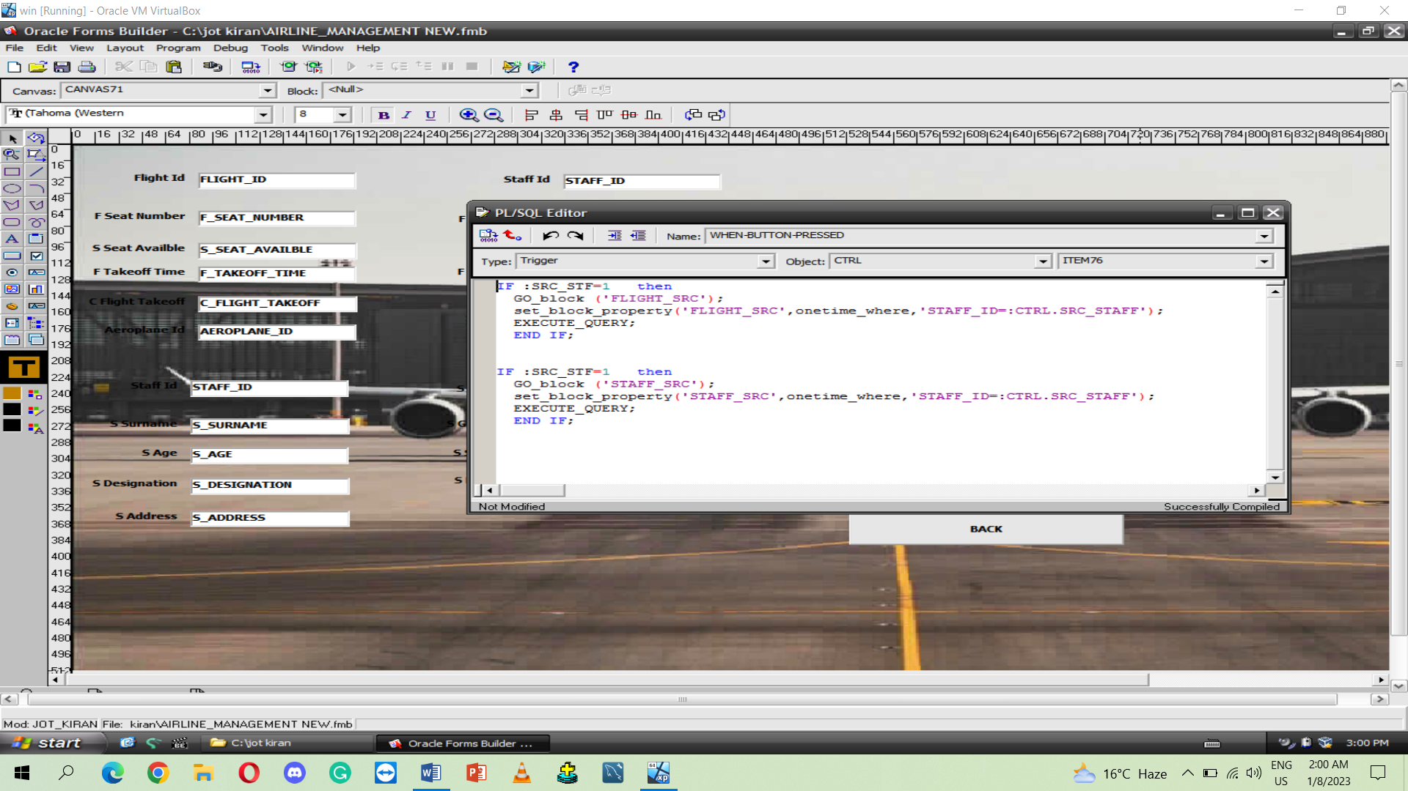

**PREVIOUS RECORD BUTTON QUERY**

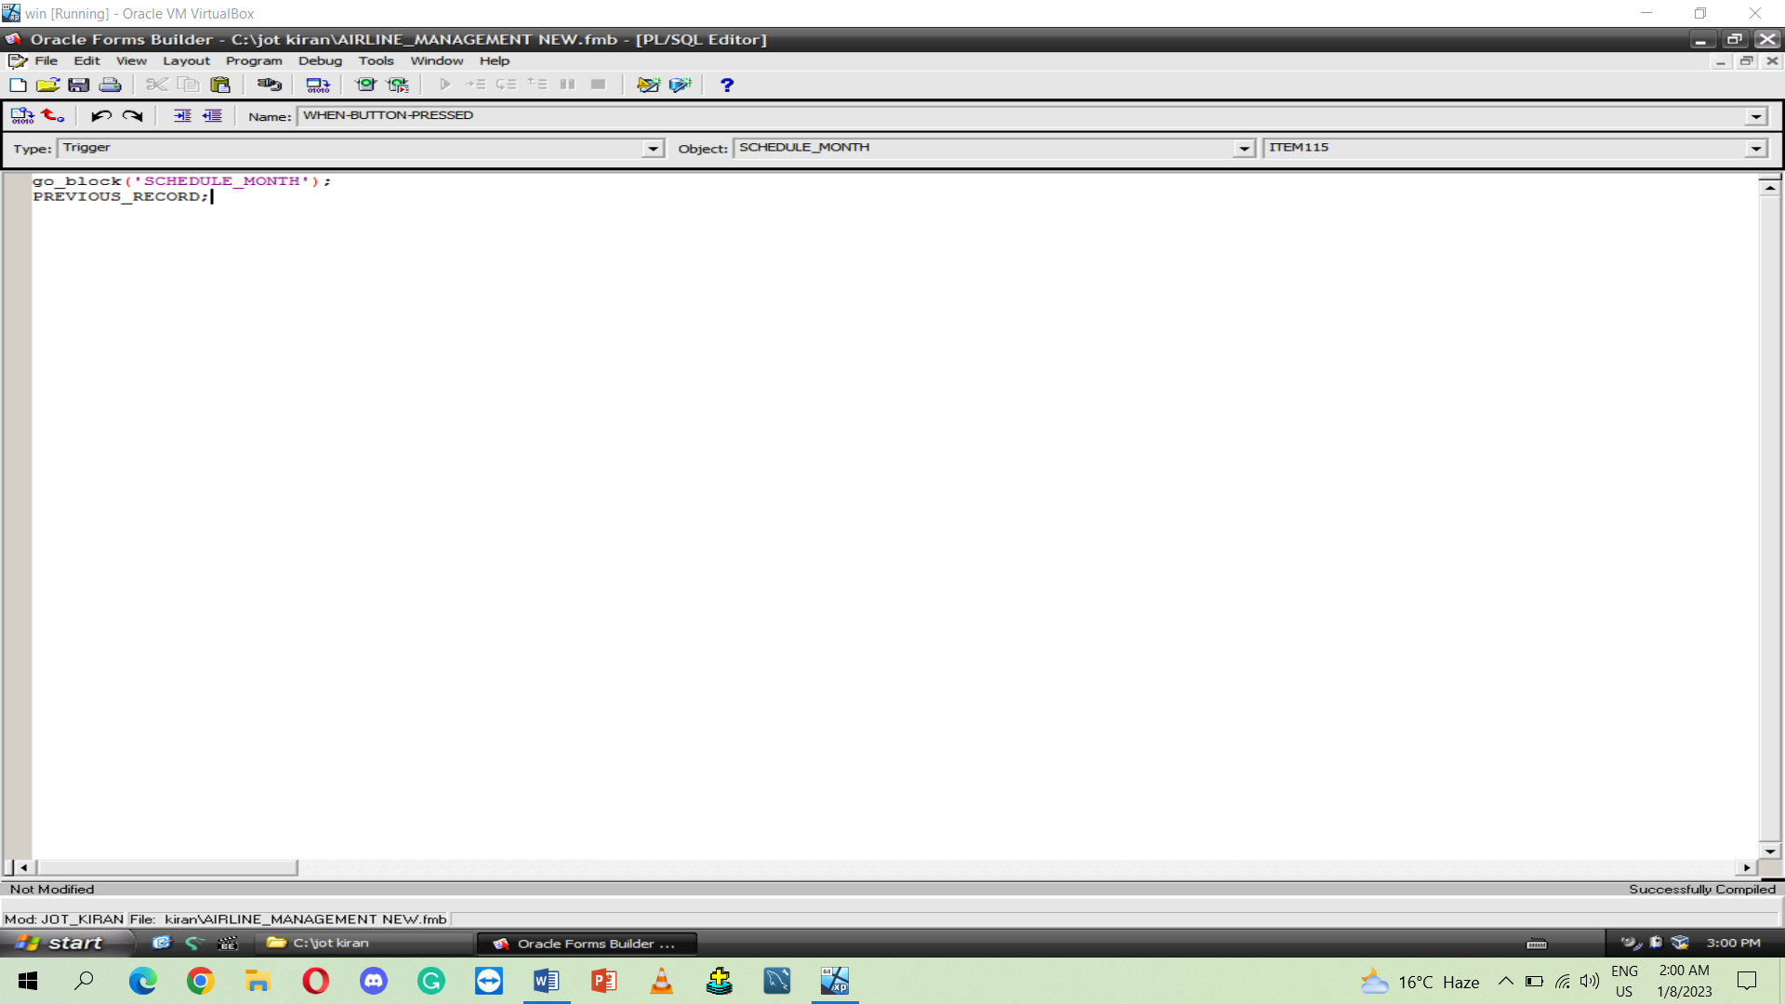

**NEXT RECORD BUTTON QUERY**

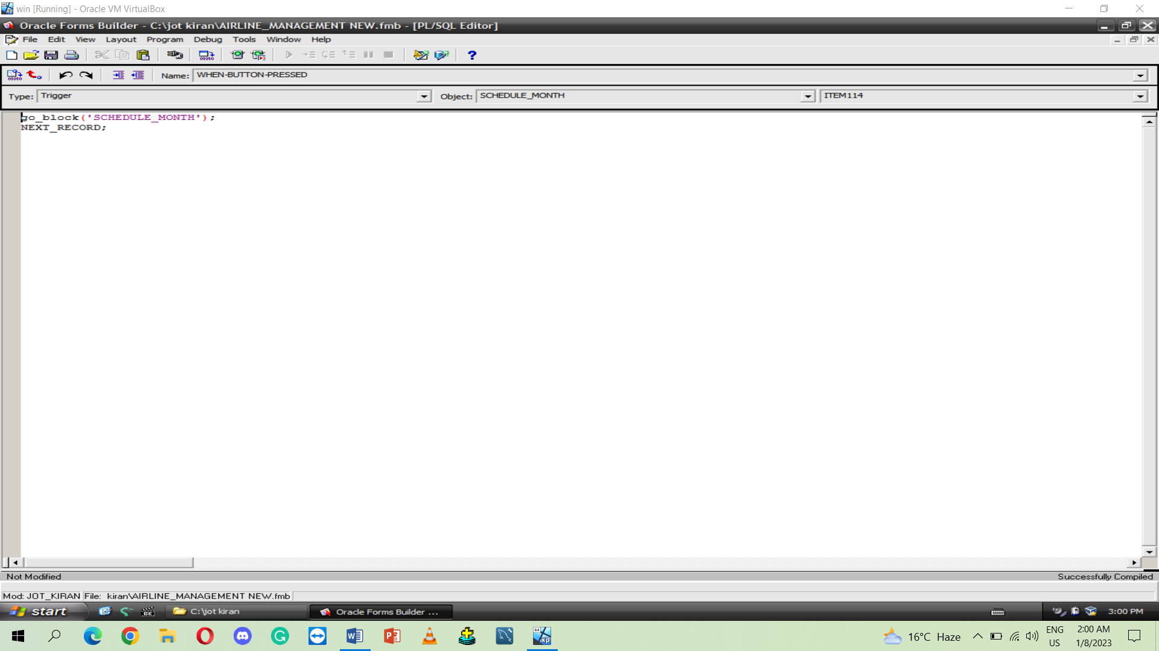

**Create backend for USER INTEREFACE**

**User table**

CREATE TABLE User_accounts (USER_ID INT,USER_PASSWORD INT);

INSERT INTO USER_ACCOUNTS

VALUES ('10060164','10060164');

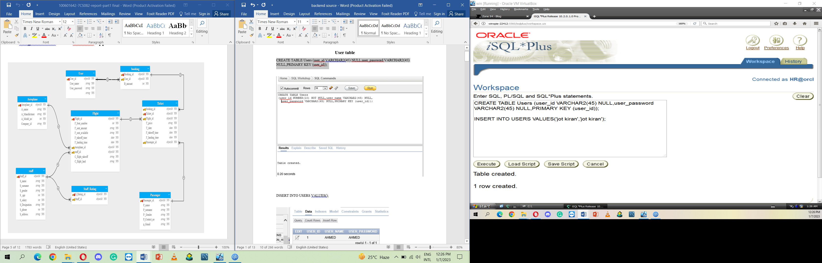

**Booking table**

CREATE TABLE booking (booking_id NUMBER(10) NOT NULL,b_amount NUMBER(10) NULL, user_id varchar2(40),PRIMARY KEY (booking_id),

CONSTRAINT fk_booking_user

FOREIGN KEY (user_id)

REFERENCES users (user_id));

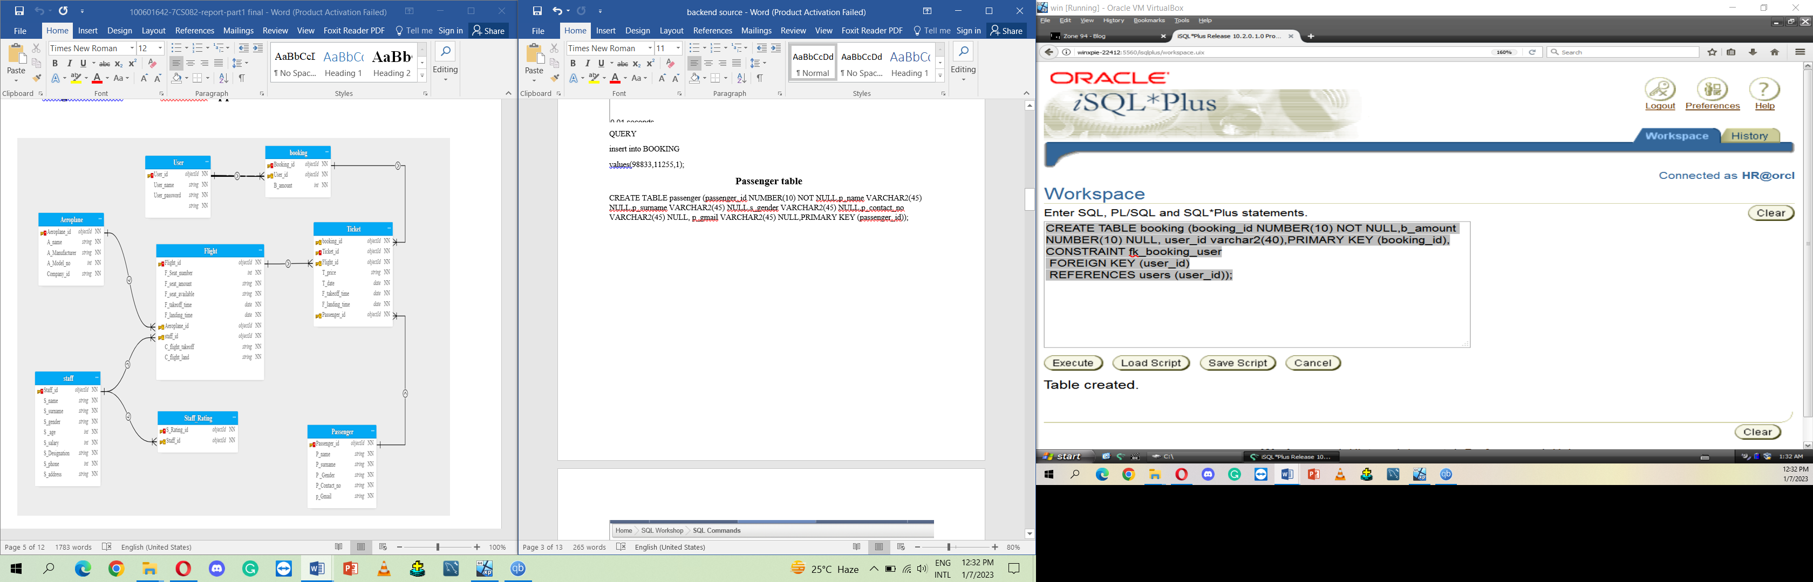

insert into BOOKING

values(98833,11255,'jot kiran');

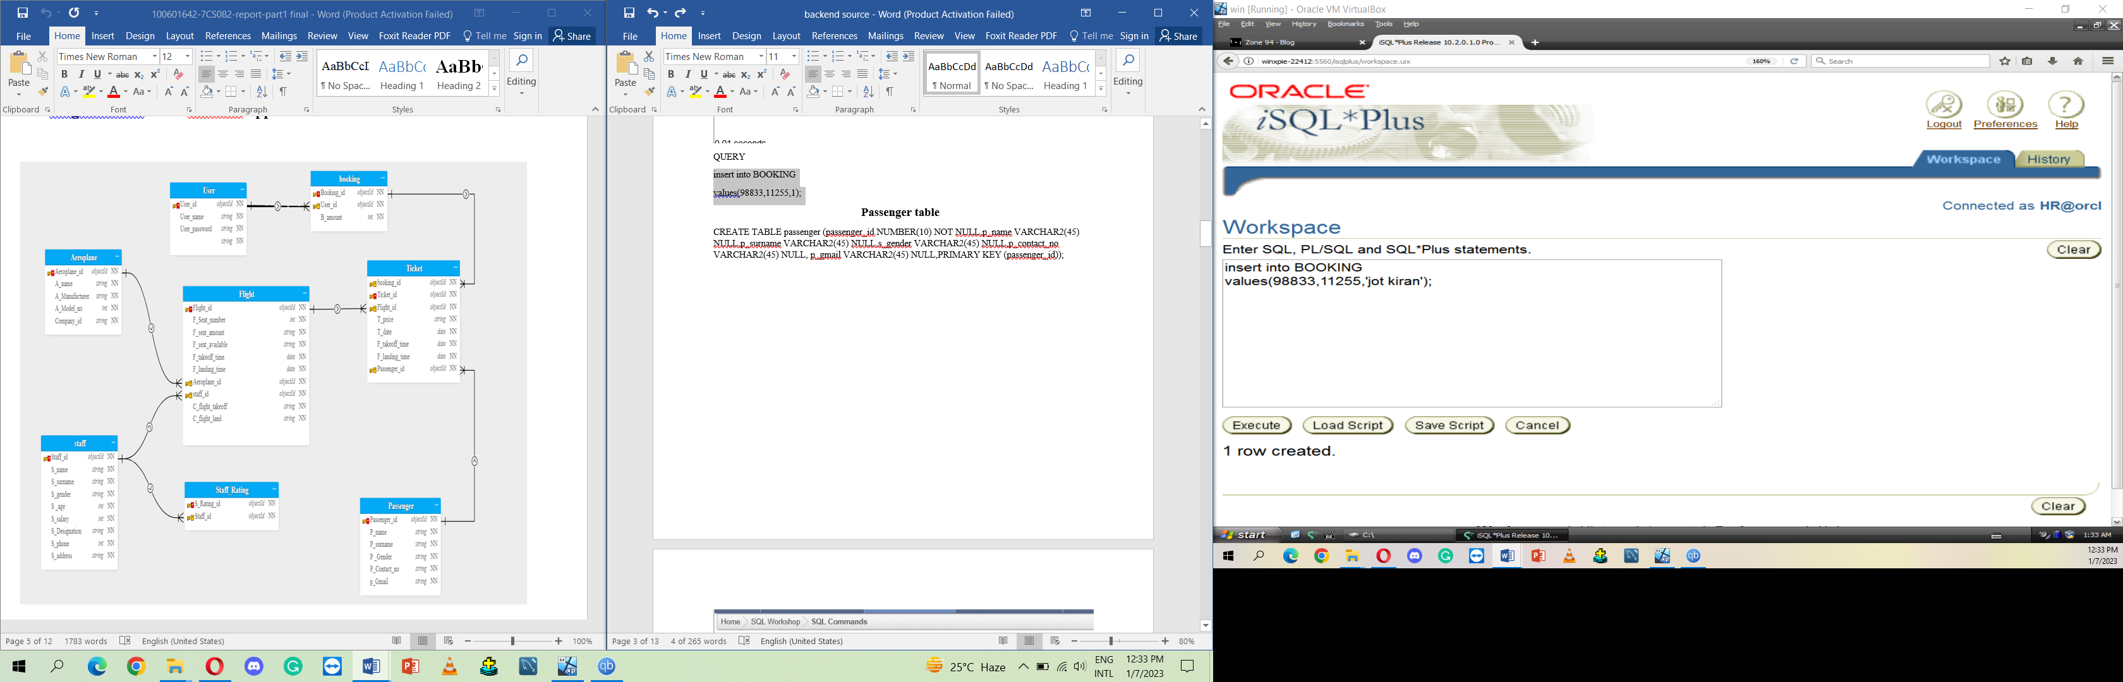

**Passenger table**

CREATE TABLE passenger (passenger_id NUMBER(10) NOT NULL,p_name VARCHAR2(45) NULL,p_surname VARCHAR2(45) NULL,s_gender VARCHAR2(45) NULL,p_contact_no VARCHAR2(45) NULL, p_gmail VARCHAR2(45) NULL,PRIMARY KEY (passenger_id));

**insert into passenger**

**values(10001,'SARAMG','SARKI','MALE',92454533441,'WWW. SARKI@.GAMIL.COM');**

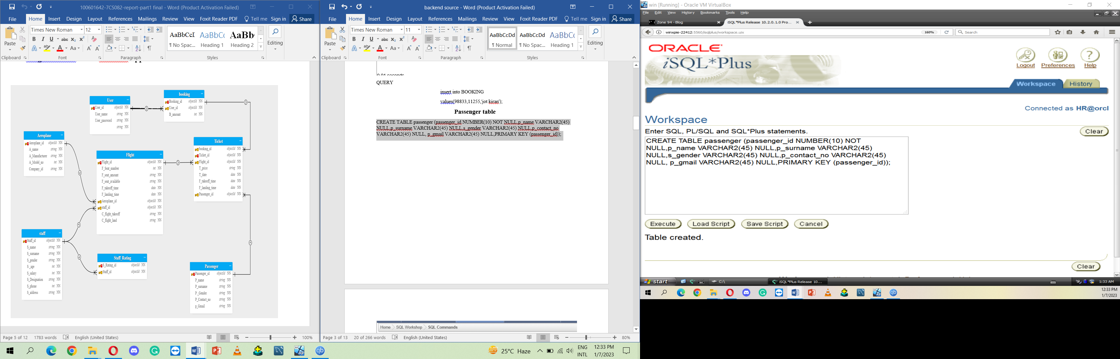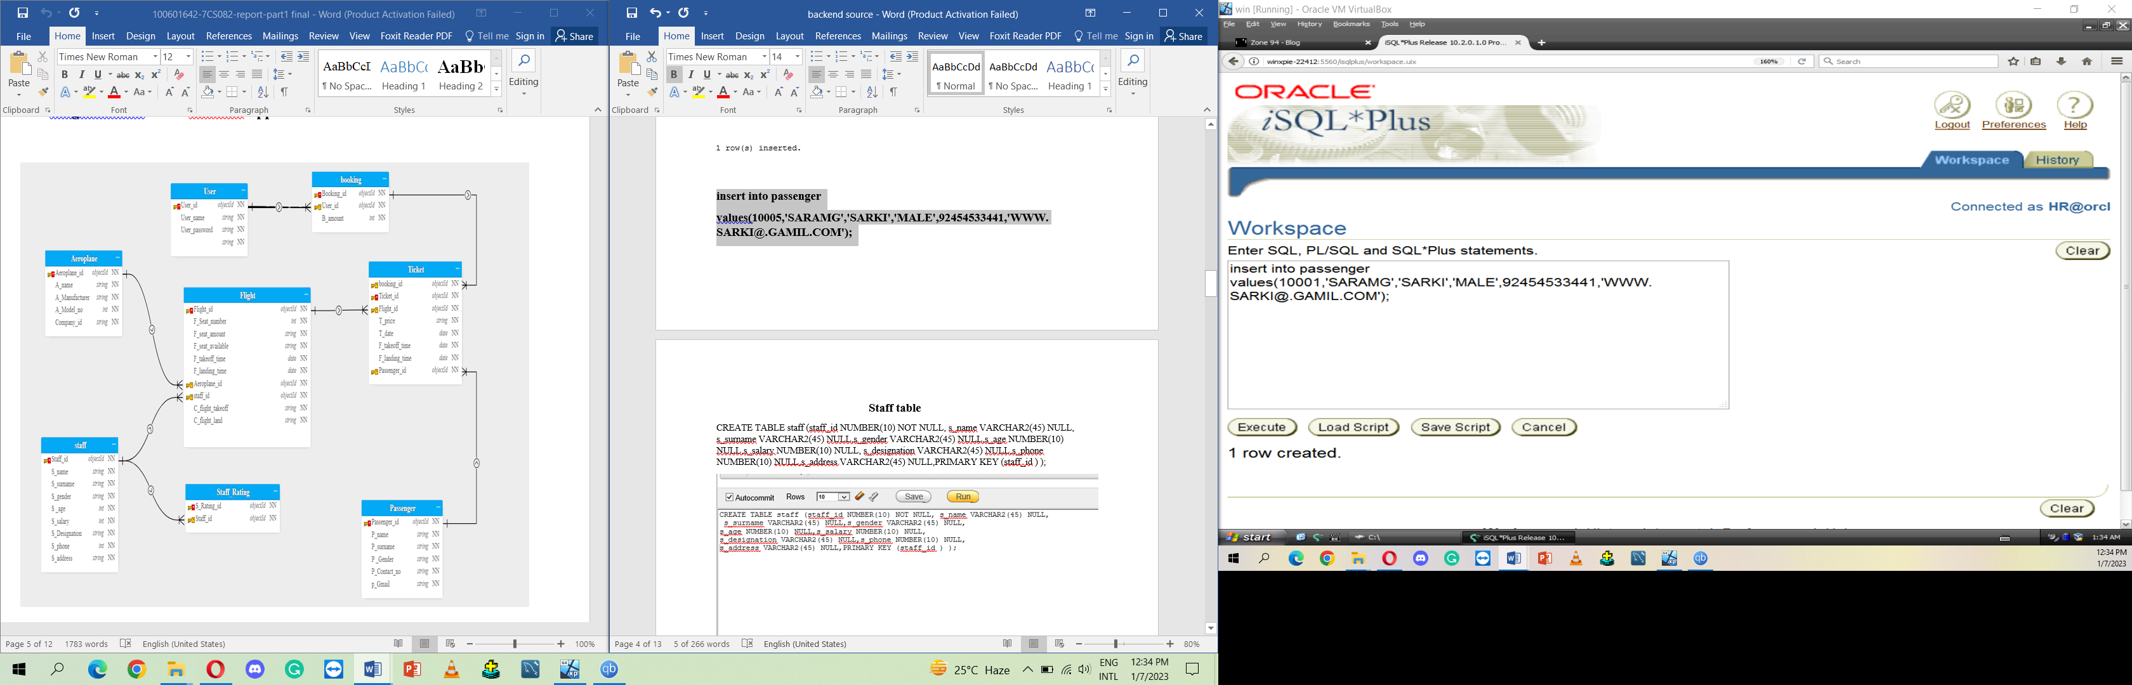

**Staff table**

CREATE TABLE staff (staff_id NUMBER(10) NOT NULL, s_name VARCHAR2(45) NULL, s_surname VARCHAR2(45) NULL,s_gender VARCHAR2(45) NULL,s_age NUMBER(10) NULL,s_salary NUMBER(10) NULL, s_designation VARCHAR2(45) NULL,s_phone NUMBER(10) NULL,s_address VARCHAR2(45) NULL,PRIMARY KEY (staff_id ) );

**insert into Staff**

**values(190001,'Abha','Singh','Male',9120211341,200000,'receptionists',012345,'Air India ,Air Indian Express,Akasa Air');**

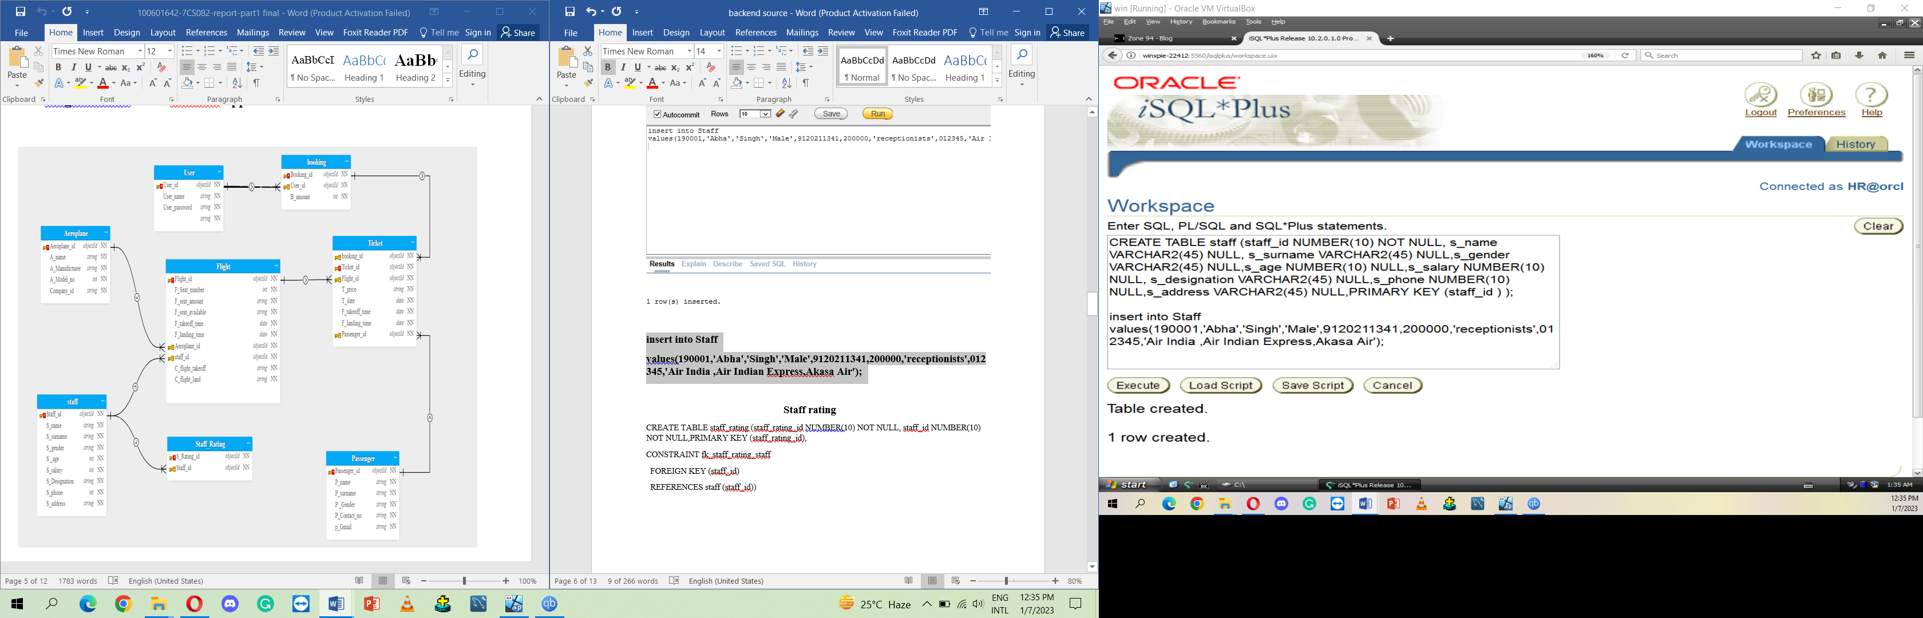

**Staff rating**

CREATE TABLE staff_rating (staff_rating_id NUMBER(10) NOT NULL, staff_id NUMBER(10) NOT NULL,PRIMARY KEY (staff_rating_id),

CONSTRAINT fk_staff_rating_staff

FOREIGN KEY (staff_id)

REFERENCES staff (staff_id));

**INSERT INTO**

**STAFF_RATING VALUES(190001,190001)**

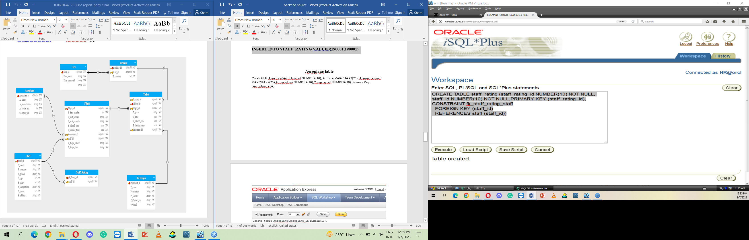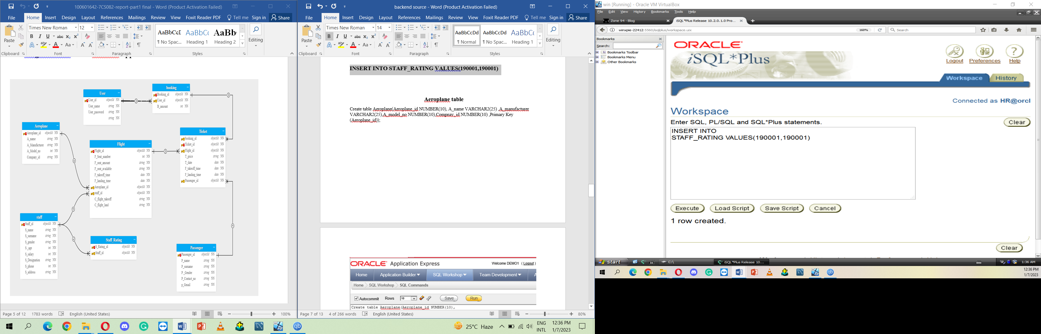

**Aeroplane table**

Create table Aeroplane(Aeroplane_id NUMBER(10), A_name VARCHAR2(25) ,A_manufacturer VARCHAR2(25),A_model_no NUMBER(10),Compnay_id NUMBER(10) ,Primary Key (Aeroplane_id));

**insert into aeroplane**

**values(111212,'PAK AIRLINE','PTA',99921,1003212);**

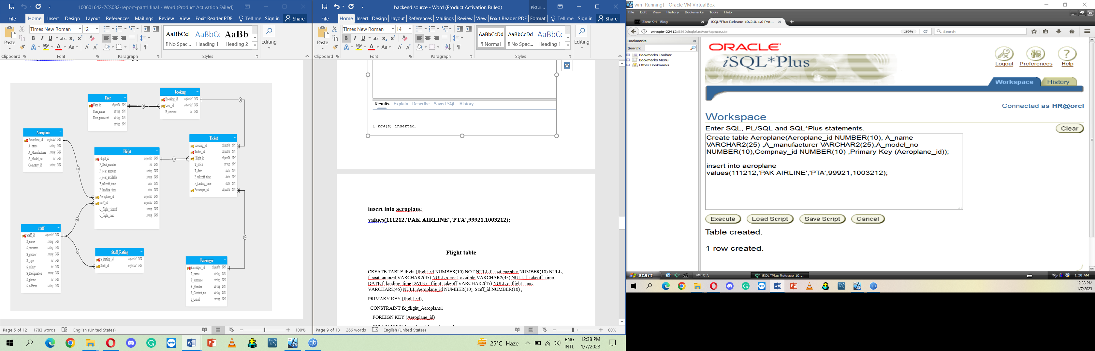

**Flight table**

CREATE TABLE flight (flight_id NUMBER(10) NOT NULL,f_seat_number NUMBER(10) NULL, f_seat_amount VARCHAR2(45) NULL,s_seat_availble VARCHAR2(45) NULL,f_takeoff_time DATE,f_landing_time DATE,c_flight_takeoff VARCHAR2(45) NULL,c_flight_land VARCHAR2(45) NULL,Aeroplane_id NUMBER(10), Staff_id NUMBER(10) ,

PRIMARY KEY (flight_id),

CONSTRAINT fk_flight_Aeroplane1

FOREIGN KEY (Aeroplane_id)

REFERENCES Aeroplane (Aeroplane_id),

CONSTRAINT fk_flight_staff

FOREIGN KEY (staff_id)

REFERENCES staff (staff_id));

**insert into flight**

**values(99934,98845,'Hyderabad','NY',to_date('13/11/2022','dd/mm/yyyy'),to_date('13/12/2022','dd/mm/yyyy'),'PENDING','PENDING','111212','190001');**

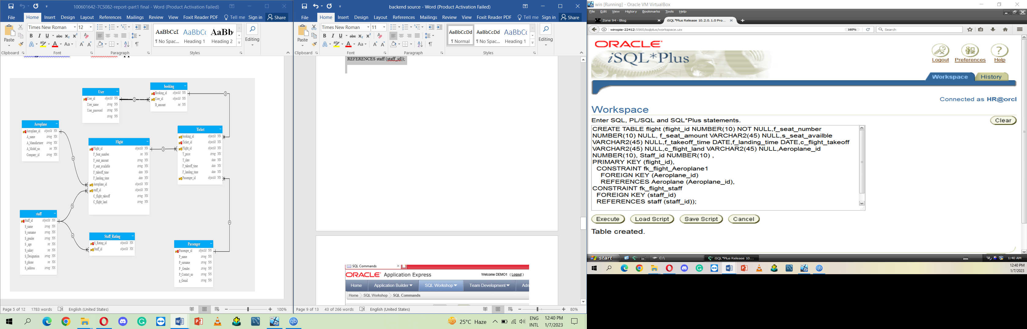

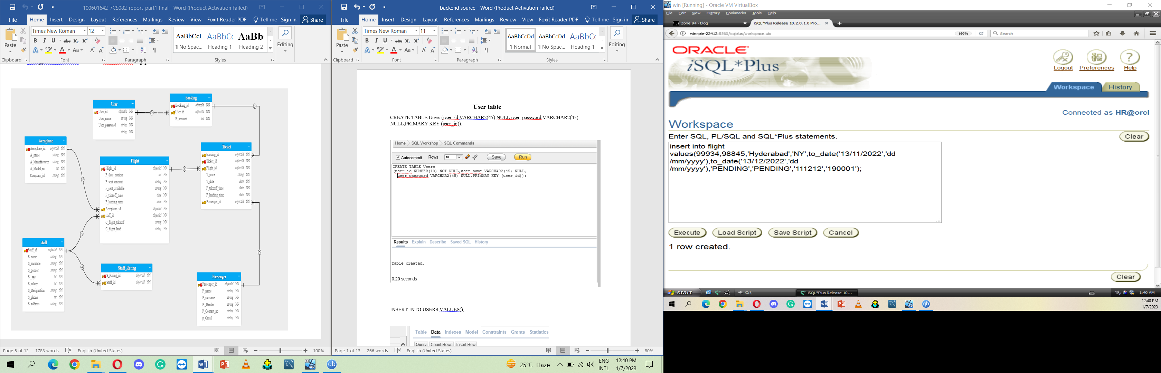

**Ticket table**

CREATE TABLE ticket (ticket_id NUMBER(10) NOT NULL,t_price NUMBER(10) NULL,t_date DATE,f_takeoff_time DATE,f_landing_time DATE,booking_id NUMBER(10) NOT NULL,passenger_id NUMBER(10) NOT NULL,Flight_id NUMBER(10) NOT NULL,

PRIMARY KEY (ticket_id),

CONSTRAINT fk_ticket_booking

FOREIGN KEY (booking_id)

REFERENCES booking (booking_id) ,

CONSTRAINT fk_ticket_passenger

FOREIGN KEY (passenger_id)

REFERENCES passenger (passenger_id),

CONSTRAINT fk_ticket_flight

FOREIGN KEY (flight_id)

REFERENCES flight (flight_id));

INSERT INTO TICKET

VALUES (1,10000,'08-jan-2020','11-jan-2020','12-jan-2020',98833,10001,99934);

